## AI Based Diabetes Prediction System

## PHASE 4(Development Part 2):

## Dataset link:  https://www.kaggle.com/datasets/mathchi/diabetes-data-set

## Tools used:

## Pandas

## NumPy

## Matplotlib

## Seaborn

## Scikit-Learn

## Mechine learning Algorithm:

## Logistic Regression

## Training the Model:

X_train, X_test, y_train, y_test = train_test_split(X, y, test_size=0.2, random_state=42)

## Code:

# Import necessary libraries

import pandas as pd

import numpy as np

from sklearn.model_selection import train_test_split

from sklearn.preprocessing import StandardScaler

from sklearn.linear_model import LogisticRegression

from sklearn.metrics import accuracy_score, classification_report, confusion_matrix

# Load your dataset

data = pd.read_csv('diabetes.csv')

# Separate features (X) and target variable (y)

X = data.drop('Outcome', axis=1)

y = data['Outcome']

# Split the dataset into training and testing sets (80% training, 20% testing)

X_train, X_test, y_train, y_test = train_test_split(X, y, test_size=0.2, random_state=42)

# Standardize features (optional but often helpful)

scaler = StandardScaler()

X_train = scaler.fit_transform(X_train)

X_test = scaler.transform(X_test)

# Create a Logistic Regression model

model = LogisticRegression(random_state=42)

# Train the model

model.fit(X_train, y_train)

# Make predictions on the test set

y_pred = model.predict(X_test)

# Evaluate the model

accuracy = accuracy_score(y_test, y_pred)

print(f'Accuracy: {accuracy:.2f}')

# Print a classification report and confusion matrix

print(classification_report(y_test, y_pred))

print(confusion_matrix(y_test, y_pred))

## Sample Output:

## 

## 

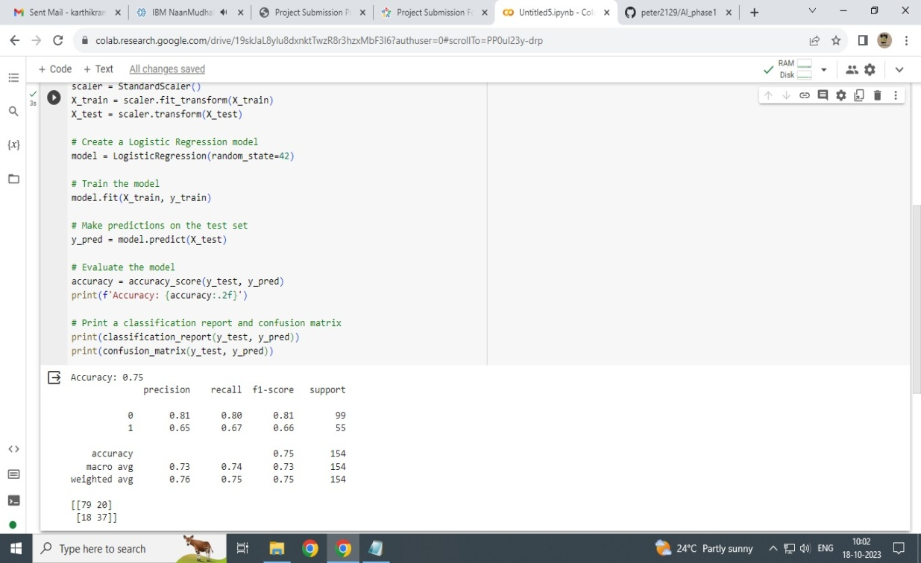

**Visualization:**

import seaborn as sns

import matplotlib.pyplot as plt

# Generate the confusion matrix

cm = confusion_matrix(y_test, y_pred)

# Create a heatmap

plt.figure(figsize=(6, 4))

sns.heatmap(cm, annot=True, fmt='d', cmap='Blues', cbar=False,

            xticklabels=['No Diabetes', 'Diabetes'],

            yticklabels=['No Diabetes', 'Diabetes'])

plt.xlabel('Predicted')

plt.ylabel('Actual')

plt.title('Confusion Matrix')

plt.show()

